Assignment 4

**Create a private bucket in AWS. Upload a file and check that through presigned URL you can access the file or not.**

**🡪**

1. Open the **Amazon Web Services** home page (aws.amazon.com).

2. Choose **Sign into Console**.

3. Sign in as **Root user** using your email address and password.

4. Go to search and search S3 (S3: Simple Storage Service).

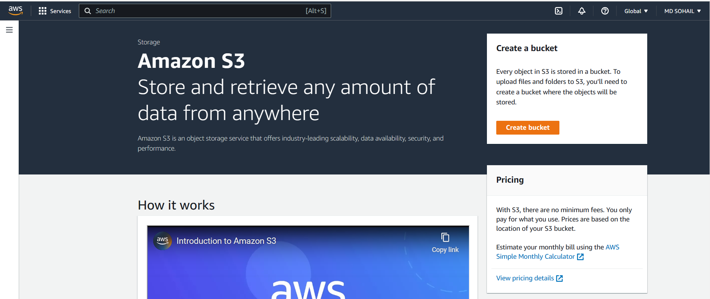

**or,** go to buckets on the side panel and click on side panel. And click on **Create bucket**.

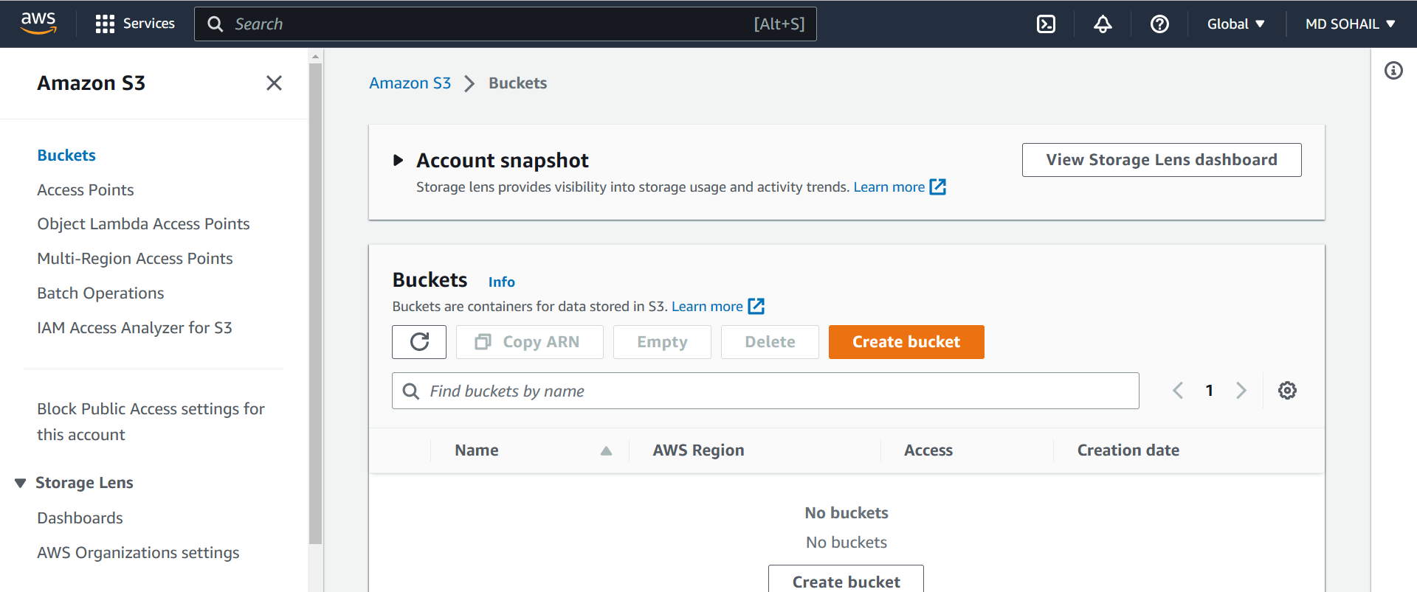

5. In **Create bucket** page:

Give globally unique name as it is created globally.

* Give the Bucket namein the General configuration section.
* Select **ACL Disabled** in the Object Ownership section.
* Check **Block all public access** in the Block Public Access settings for this bucket section.

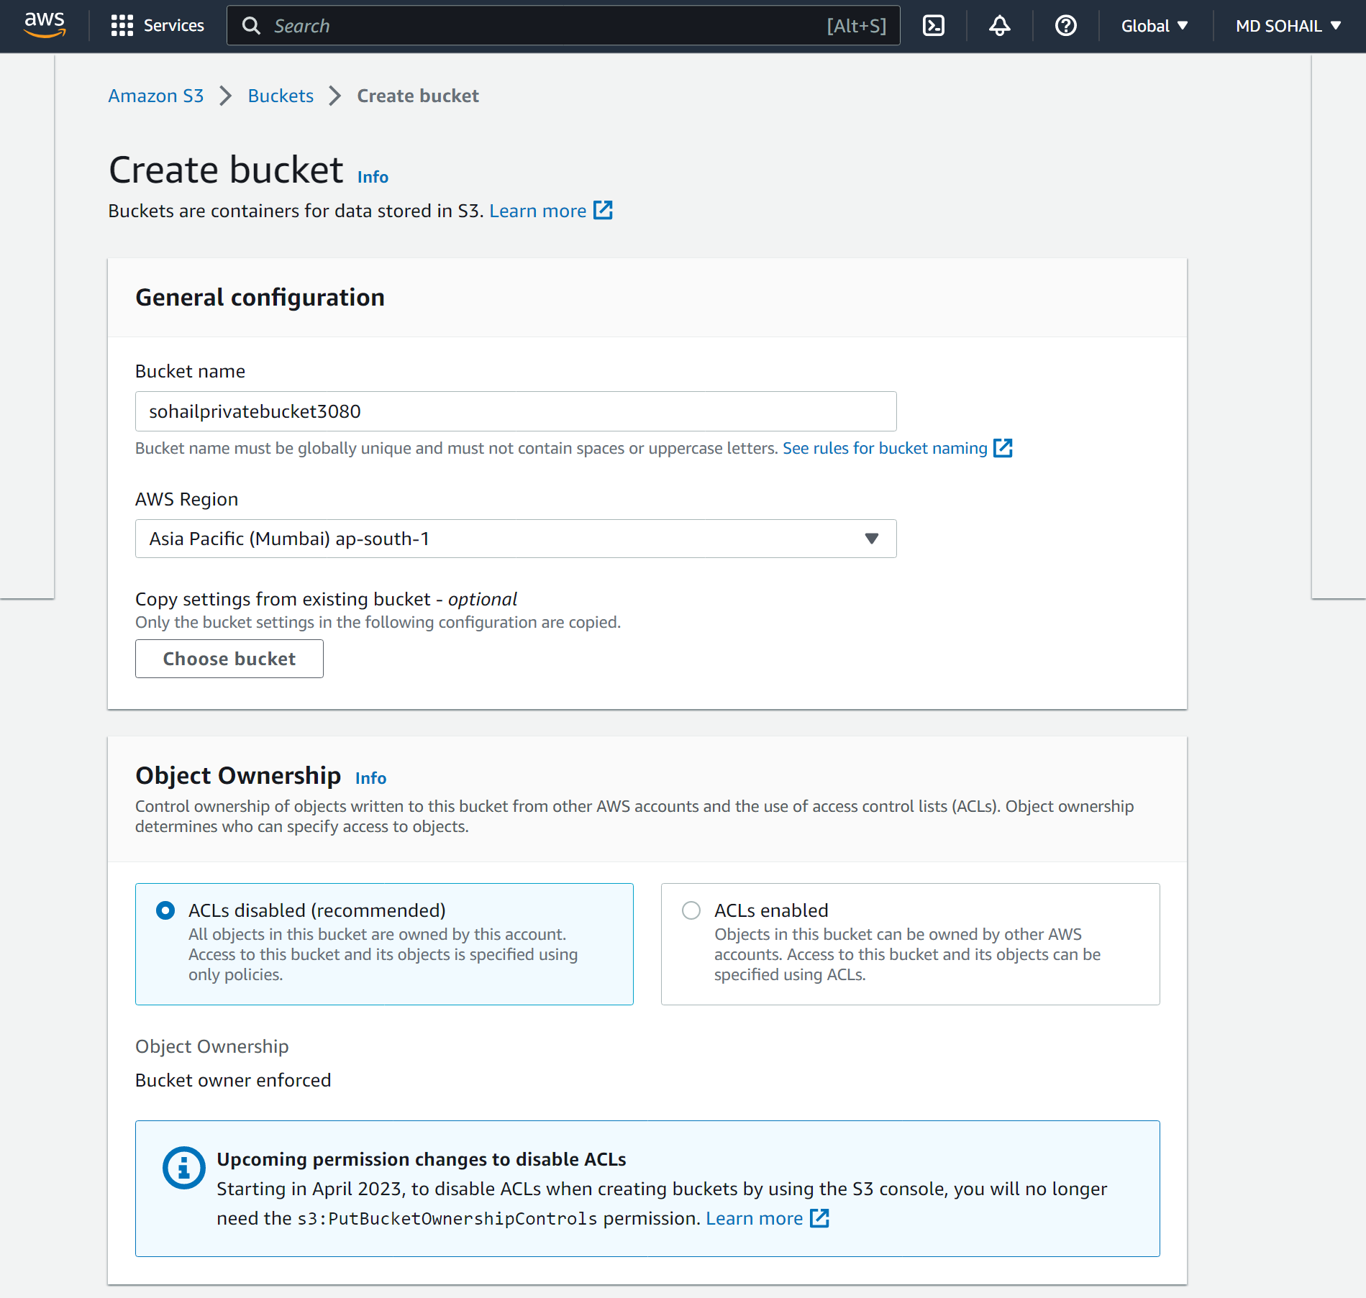

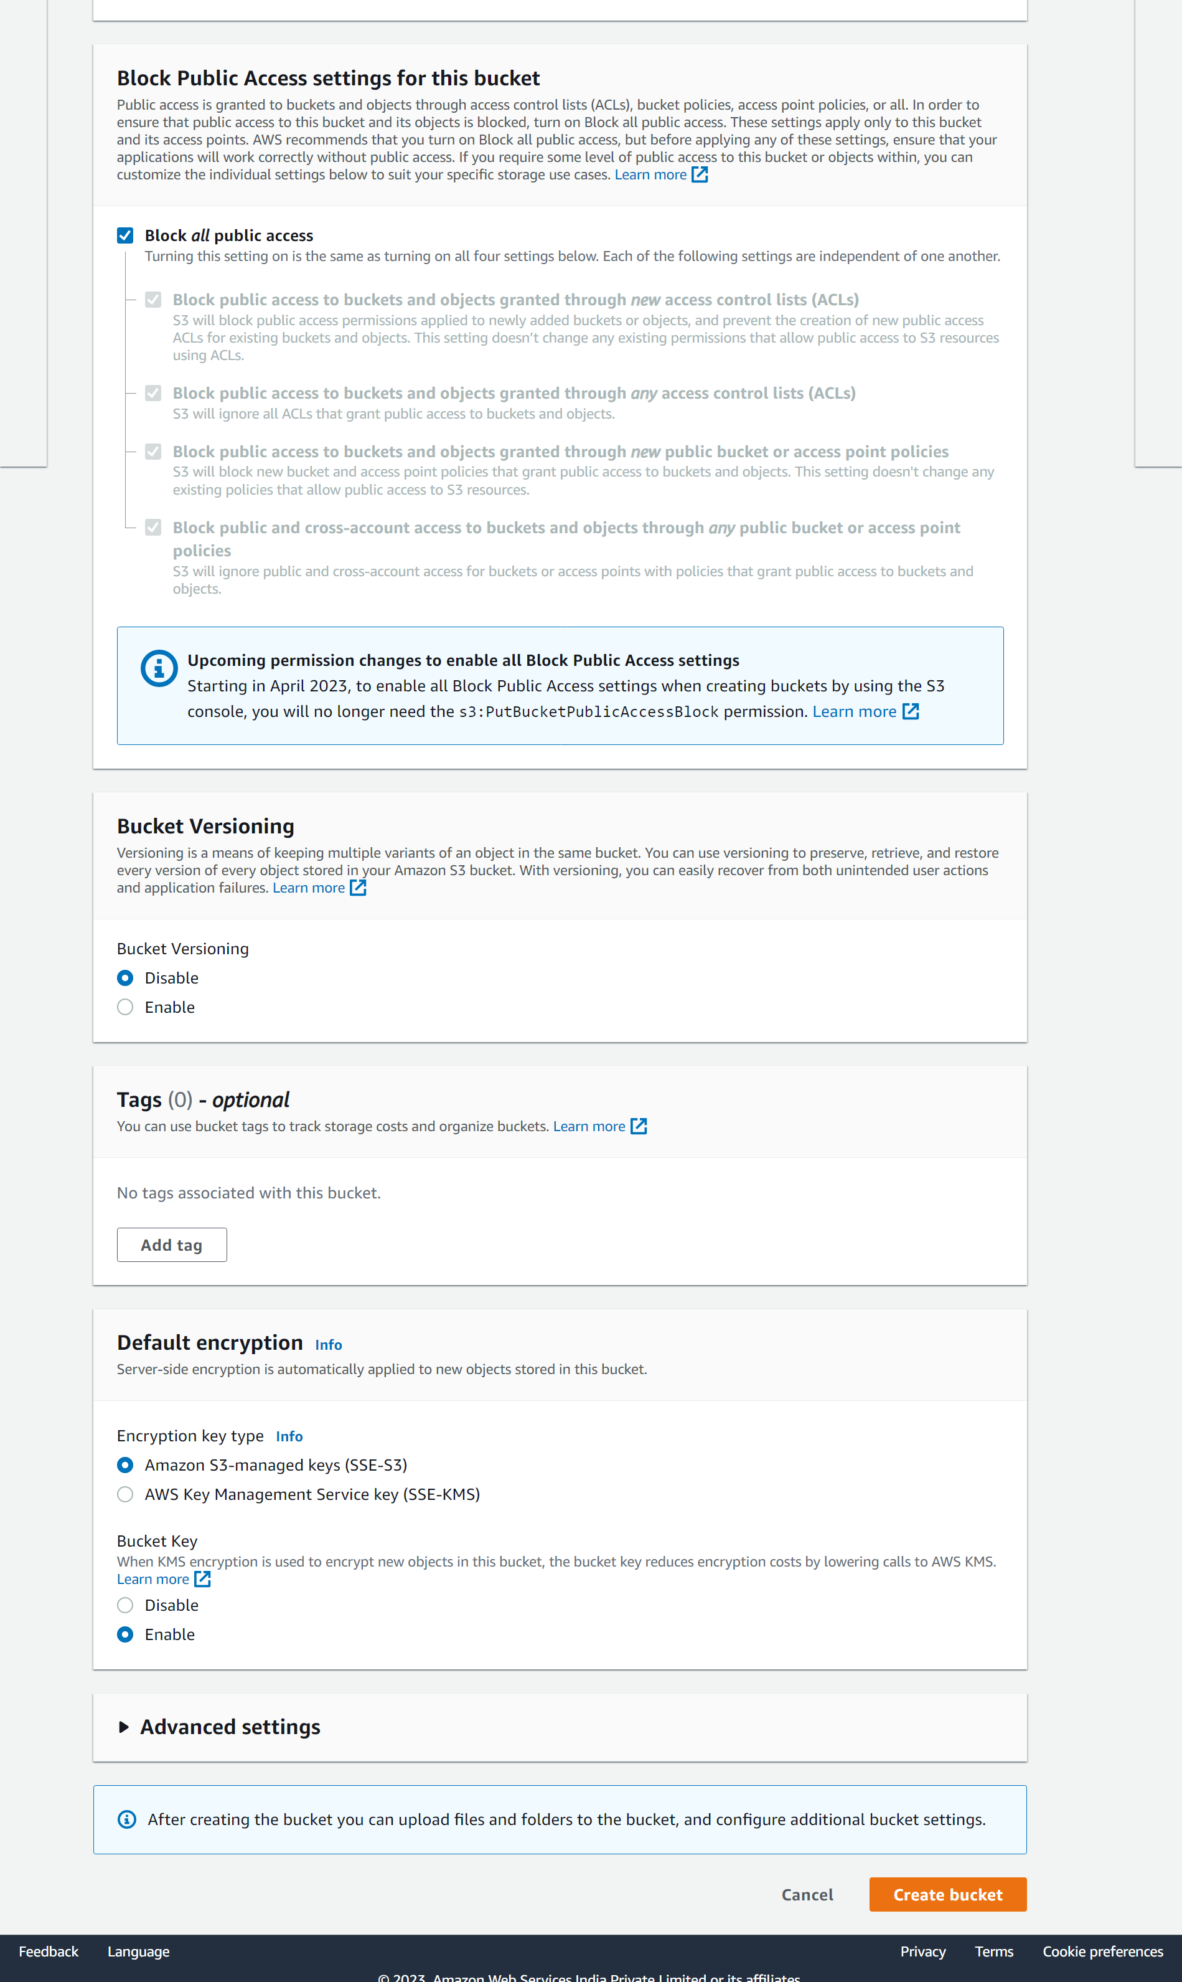

Keep other things at default and **click on Create Bucket.**

6. Now check your bucket will be created. Next Click on the bucket that you have created.

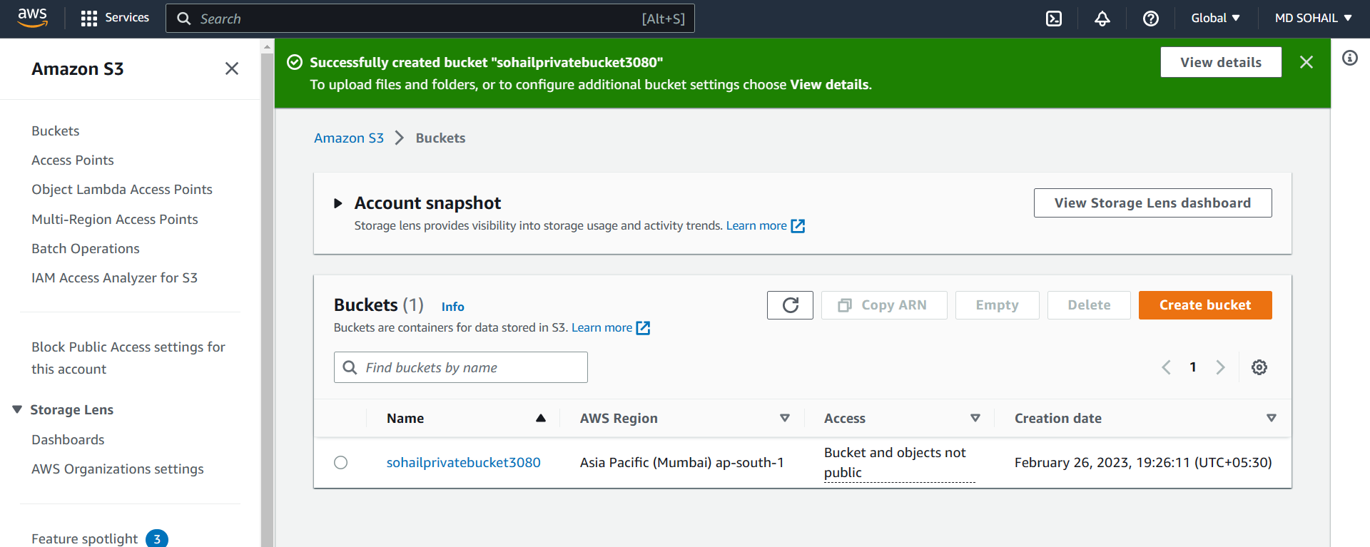

7. Then click on upload.

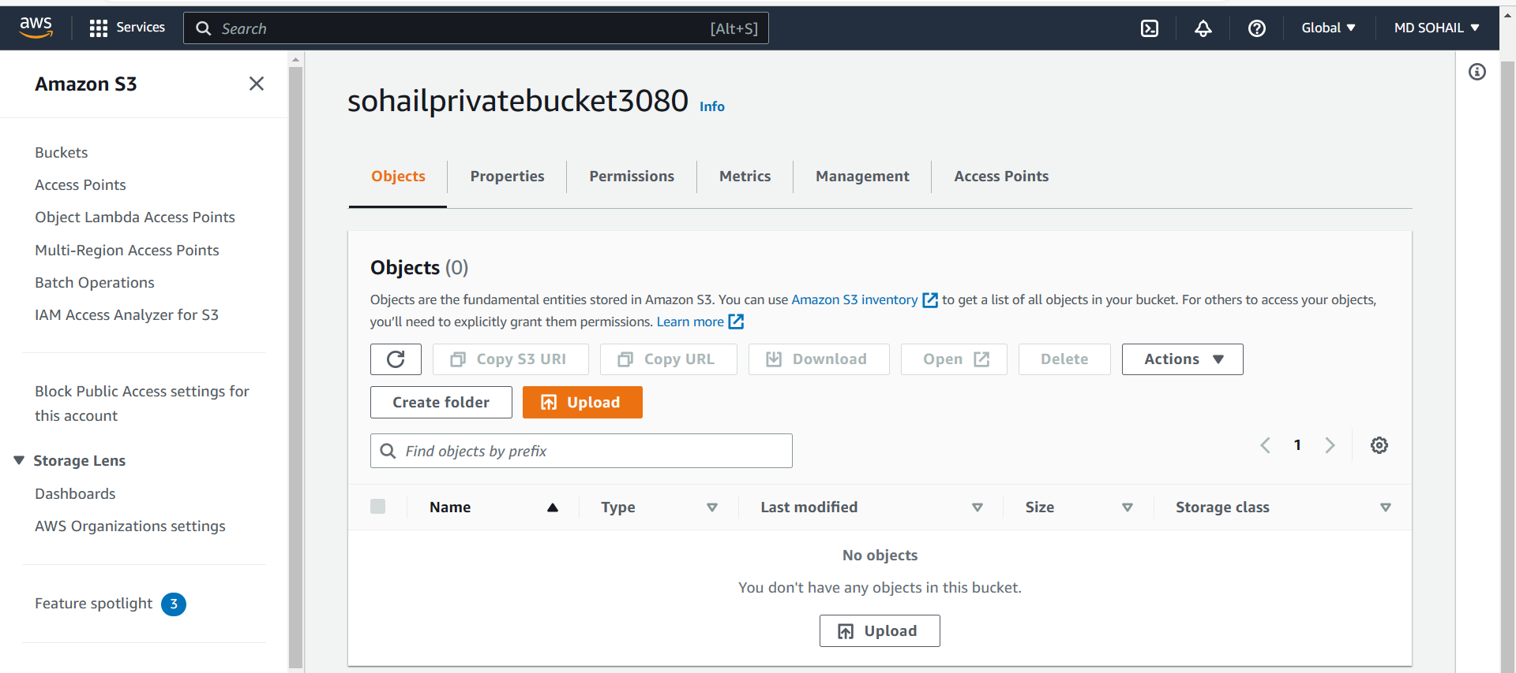

8. In Upload page:

Click on **Add files** to upload a file, select the file and click on **Upload**.

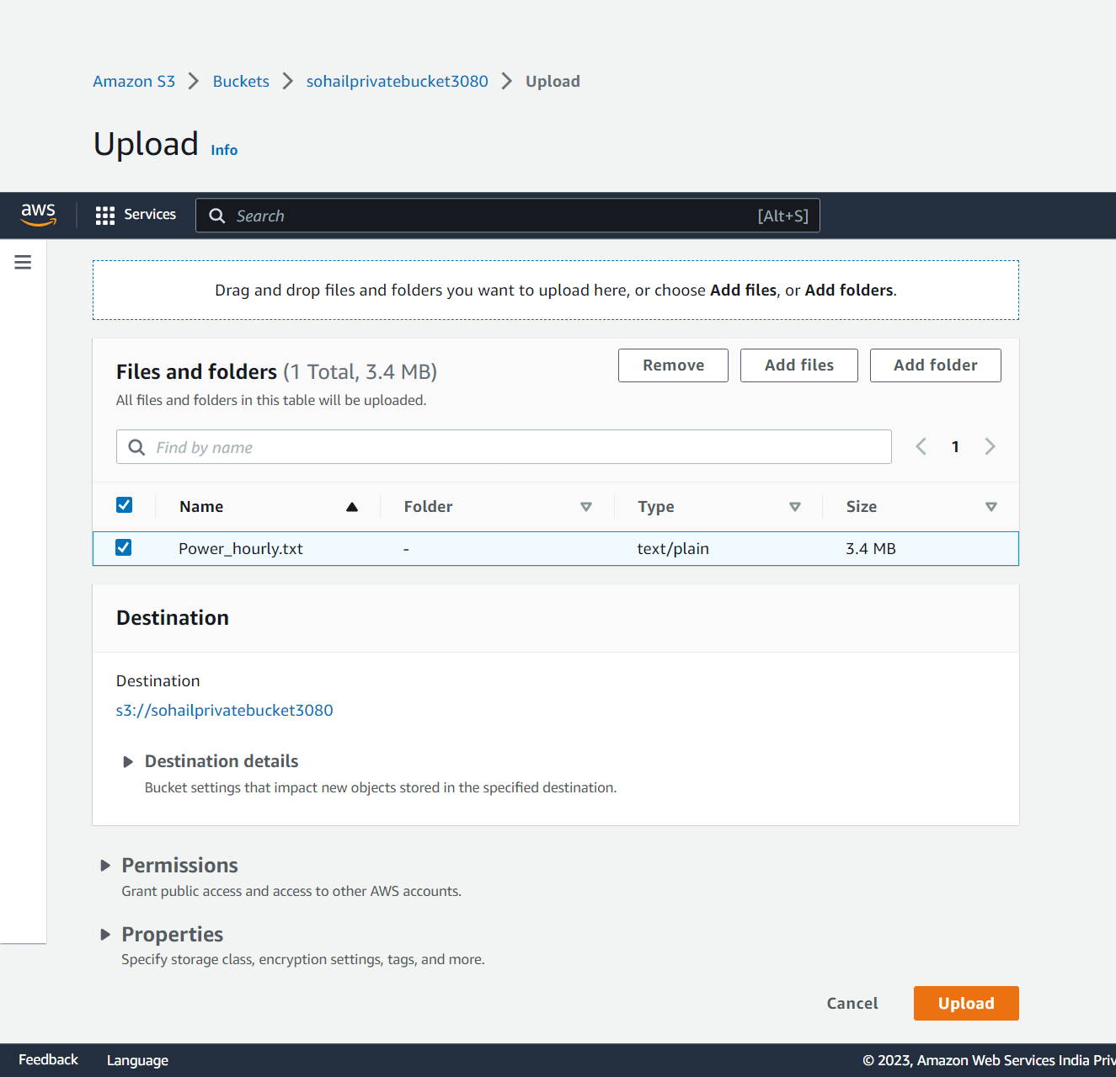

9. Then click on the file uploaded file on the upload status page.

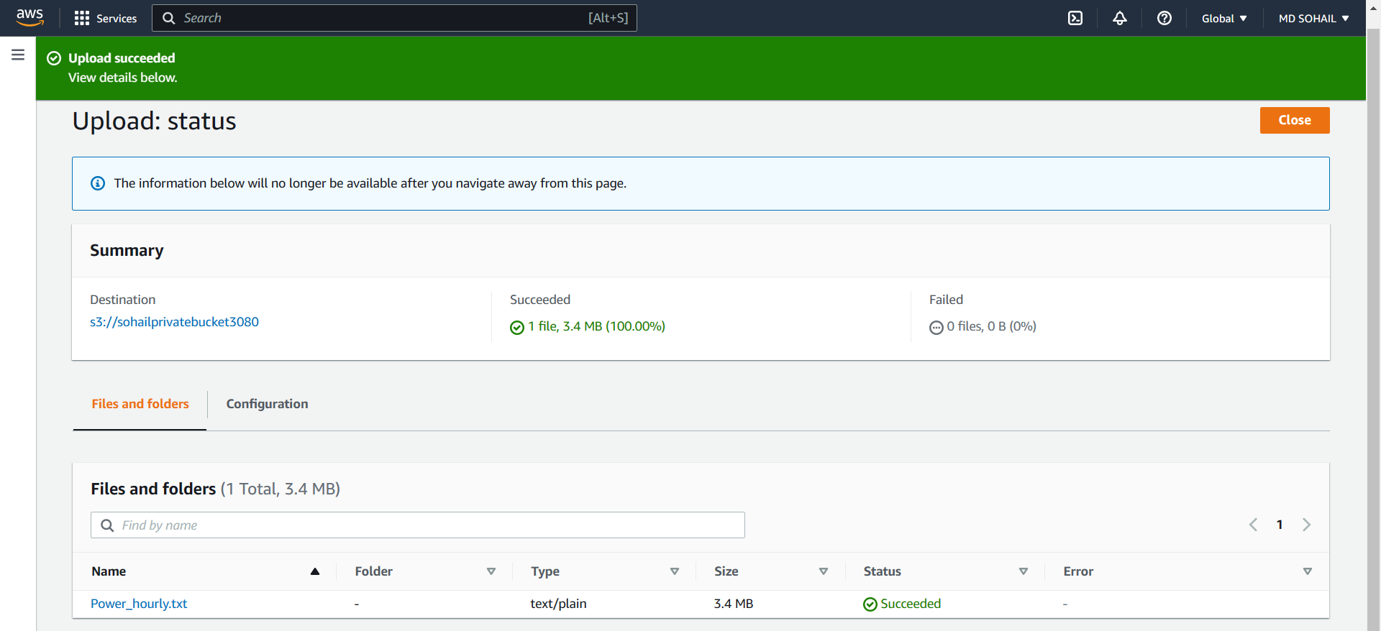

Copy the URL and open in new tab.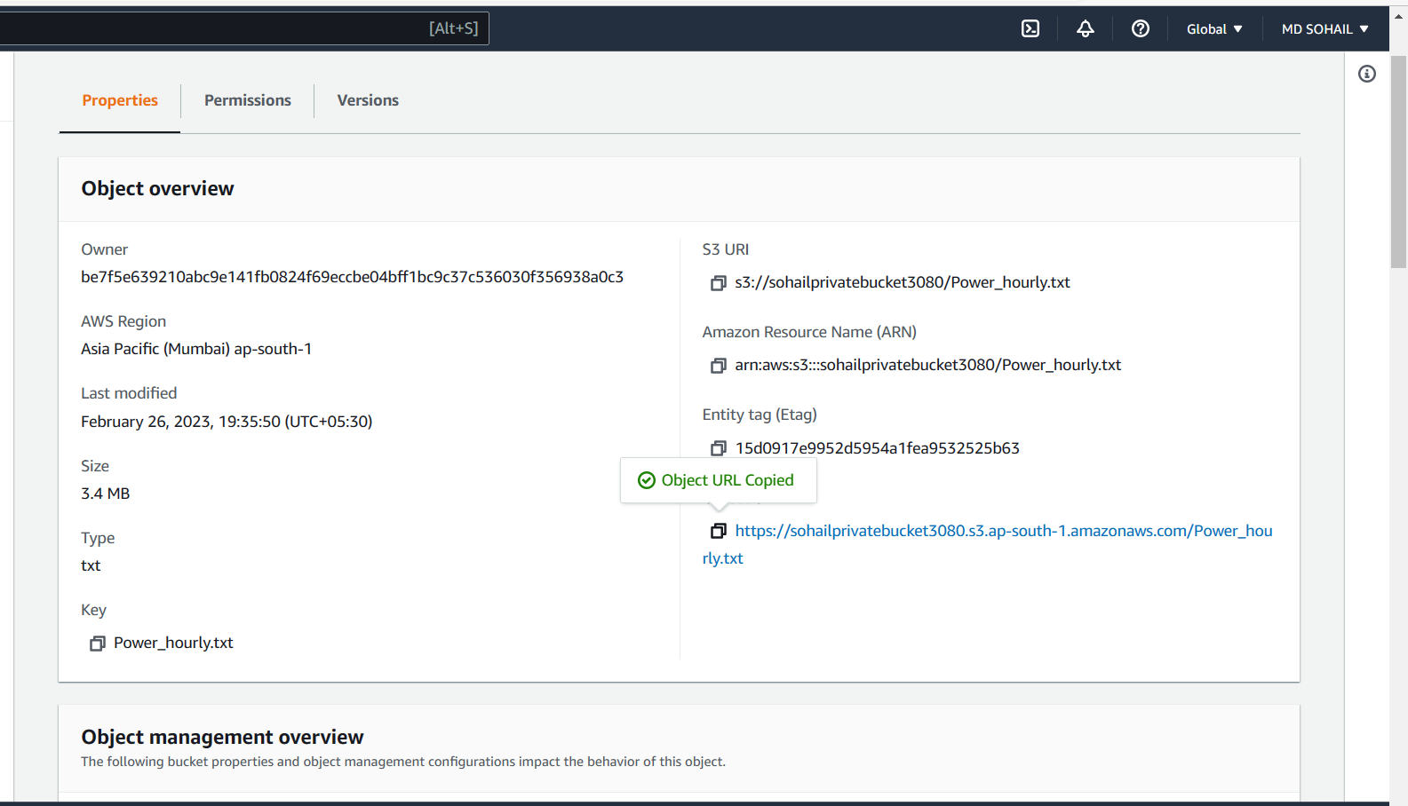

You can see Object URL cannot be accessed.

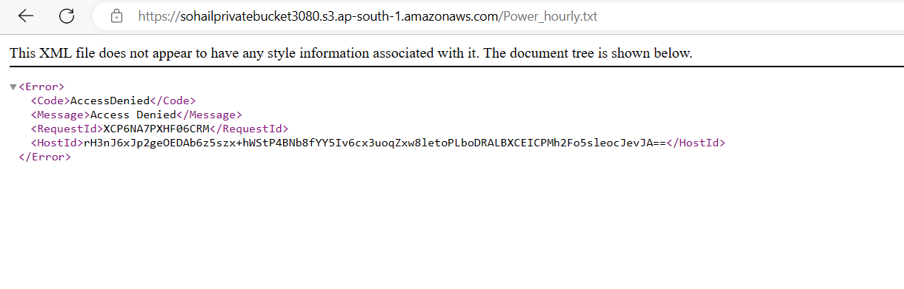

10. Go back to bucket.

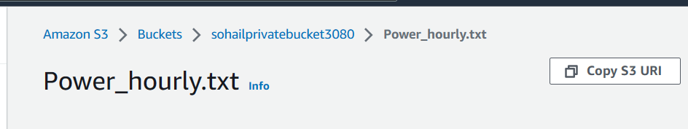

11. Select the file uploaded.

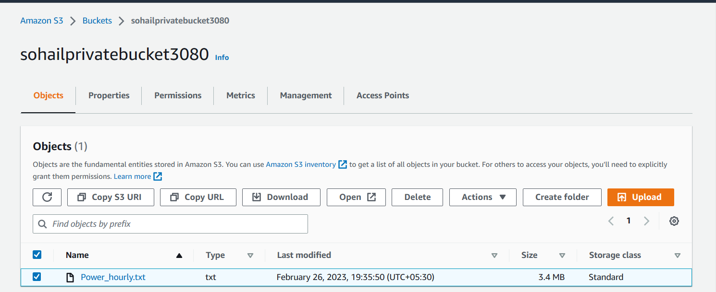

12. Then Click on action and select **Share with a presigned URL.**

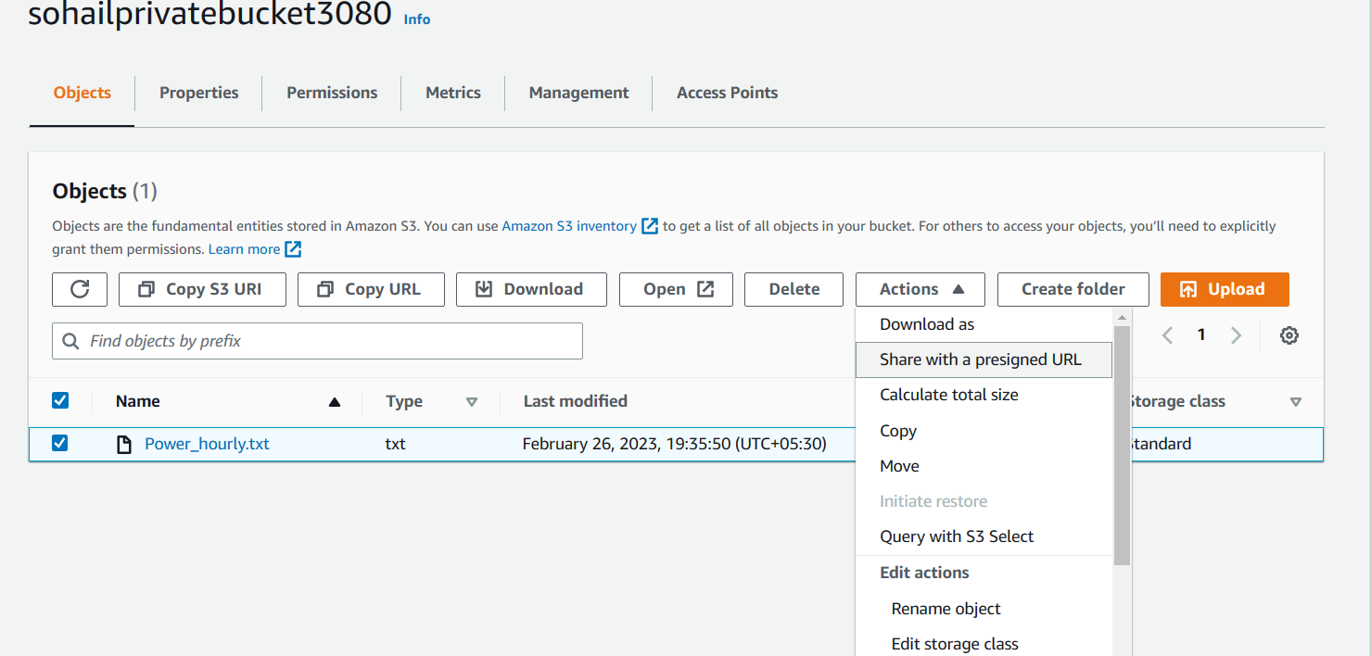

13. Give a time duration and click **Create presigned URL.**

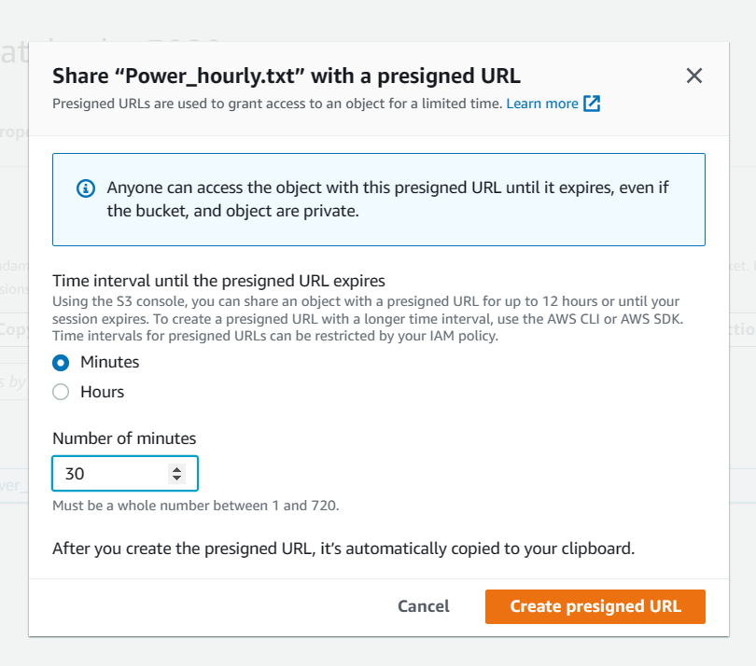

14. Copy the **presigned URL**. Go to another browser and paste the URL [We create a presigned URL because we want give a permission for a time to a private bucket].

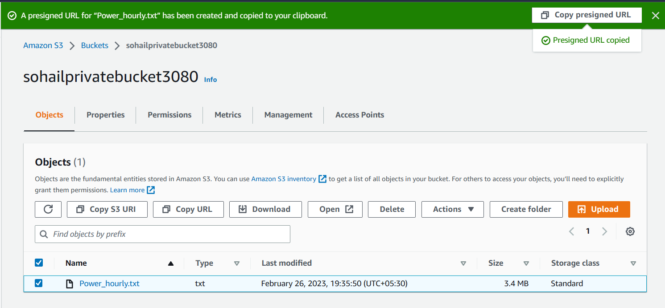

You can access the file now for the given duration assigned during creation of presigned URL.

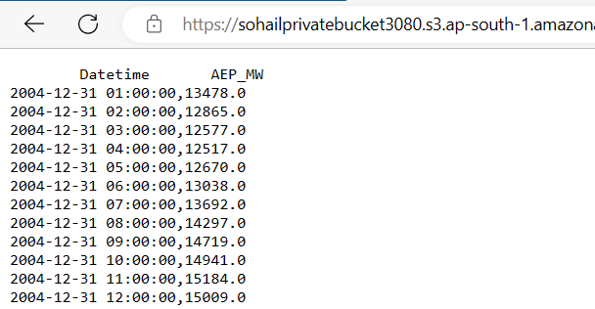

**Assignment 5**

***Create a public bucket in AWS. Upload a file and give the necessary permission to check the file URL is working or not.***

**🡪**

1. Open the **Amazon Web Services** home page (aws.amazon.com).

2. Choose **Sign into Console**. 3. Sign in as **Root user** using your email address and password. 4. Go to search and search s3 (S3: simple storage service).

**or,** go to buckets on the side panel and click on side panel. And click on **Create bucket**.

5. In **Create bucket** page:

Give globally unique name as it is created globally.

* Give the Bucket name in the General configuration section.
* Select **ACL enabled** in the Object Ownership section.
* Uncheck **Block all public access** in the Block Public Access settings for this bucket section.
* Check **I acknowledge in Turning off block all public access**.

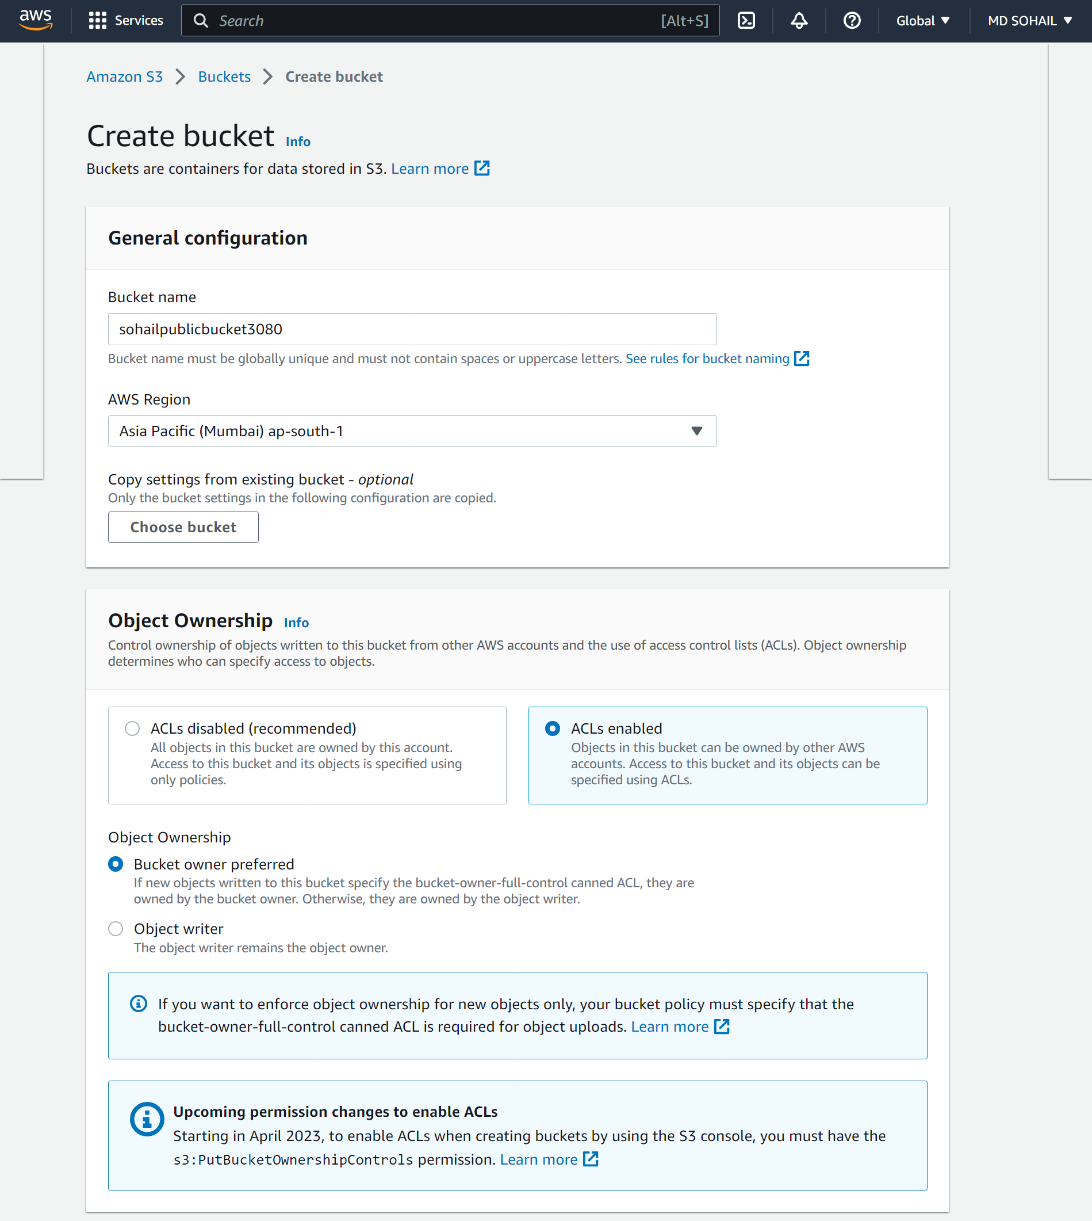

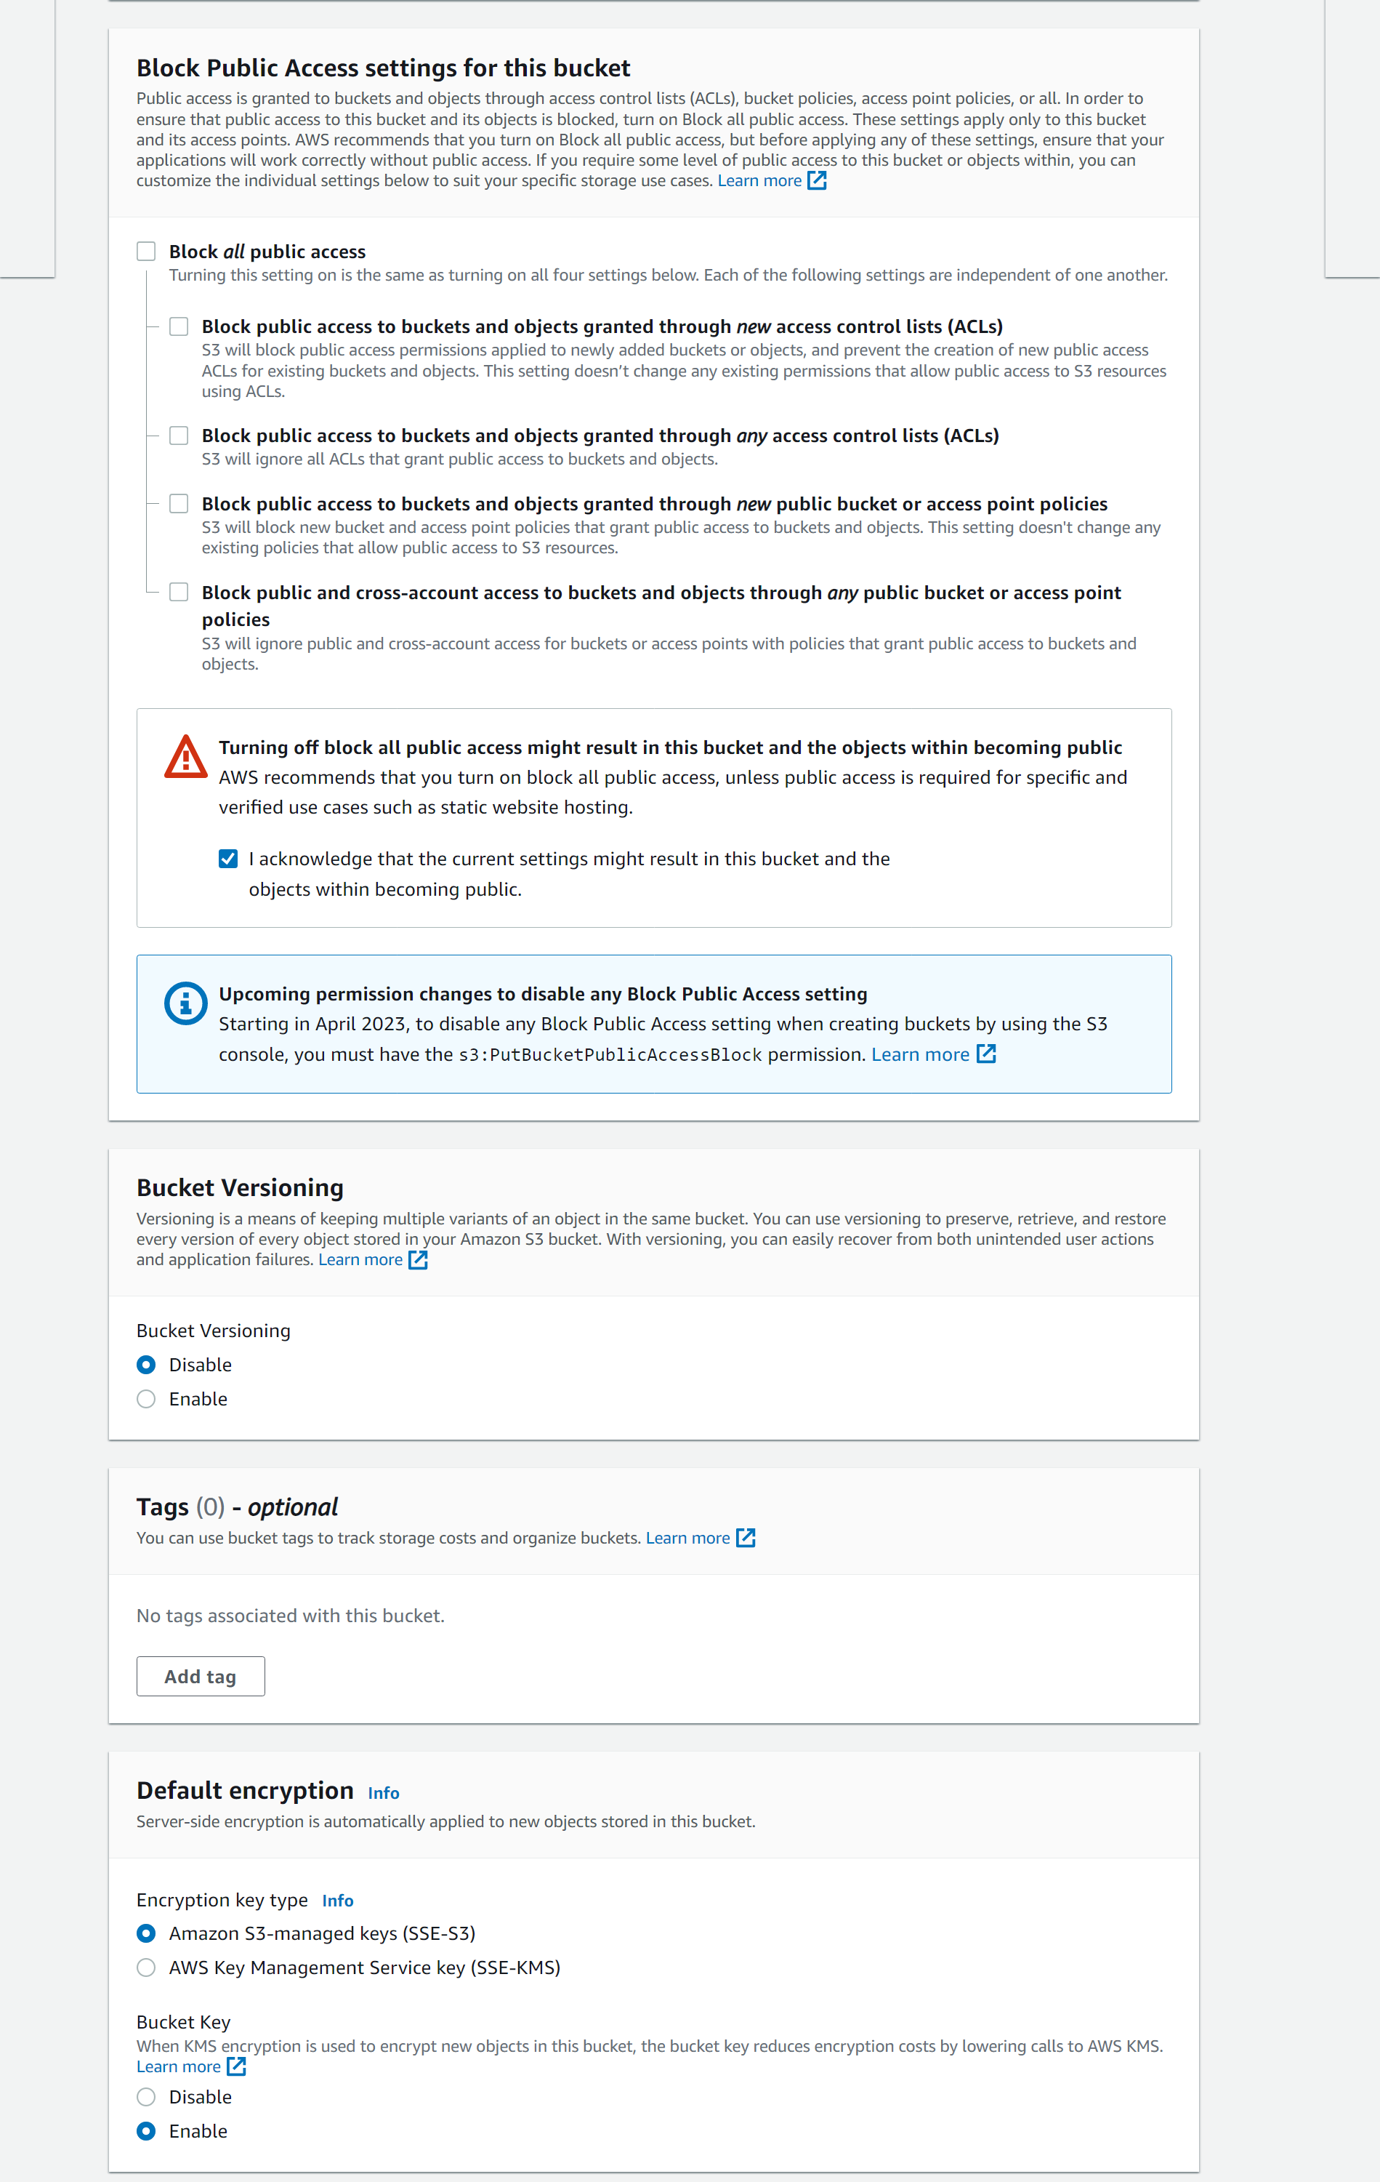

Keep other things at default and **click on Create Bucket.**

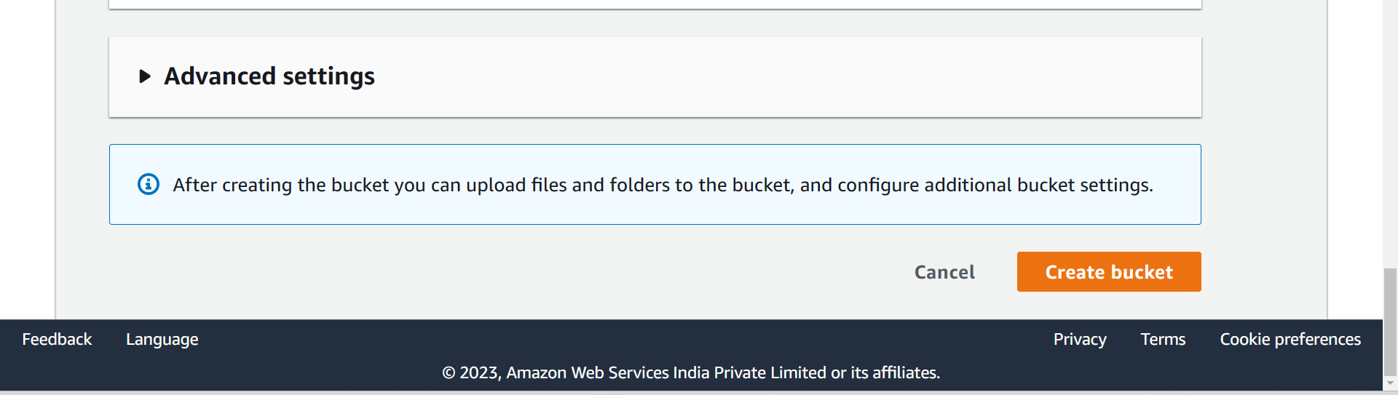

6. Now check your bucket will be created. Next Click on the bucket that you have created.

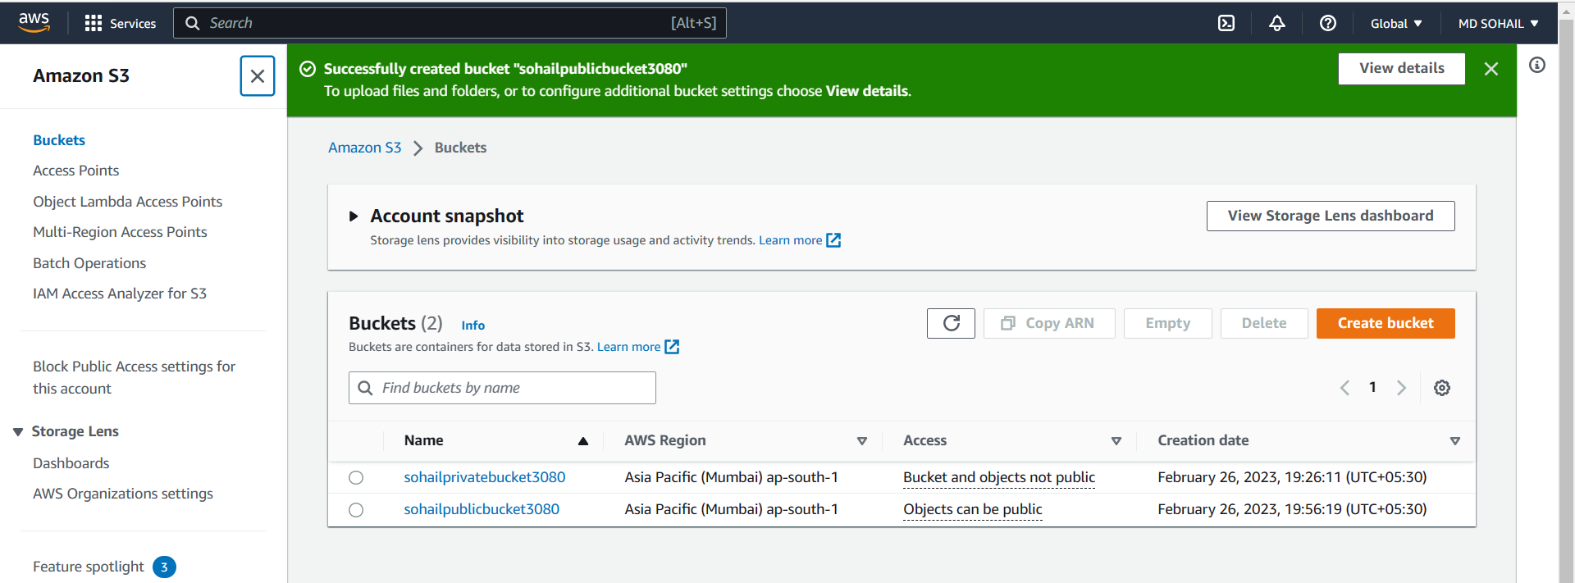

Next click on **upload**.

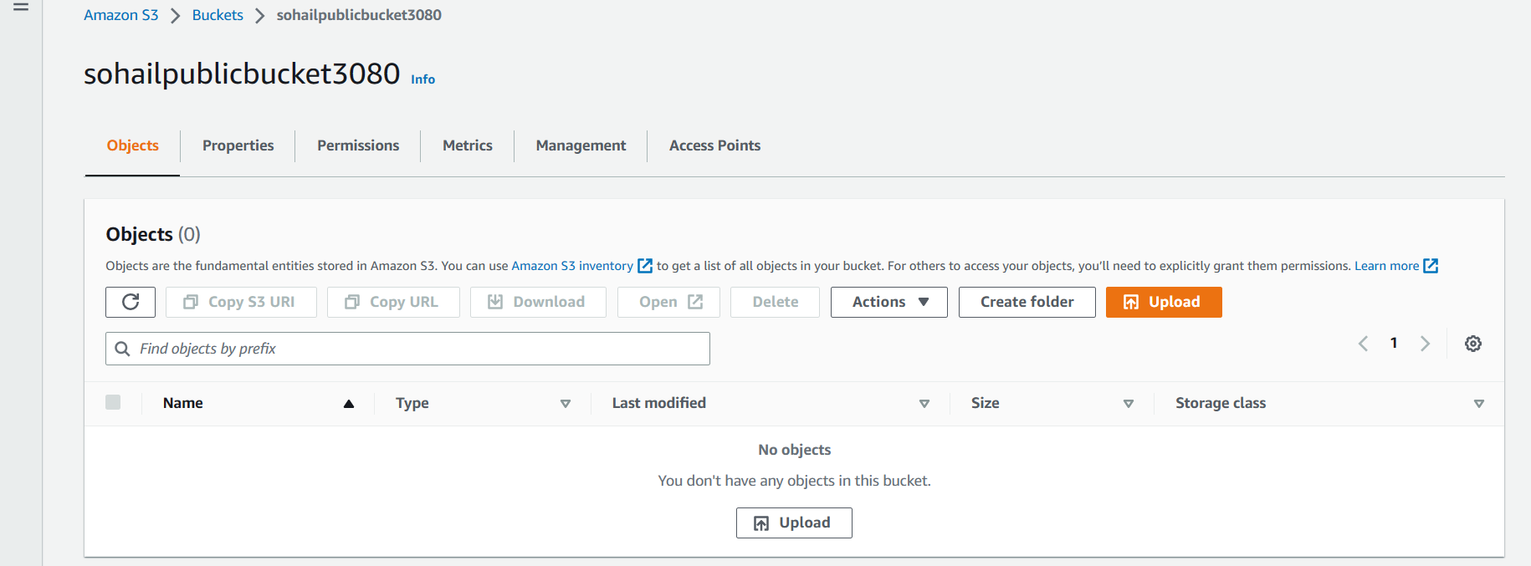

7. In Upload page:

Click on **Add files** to upload a file.

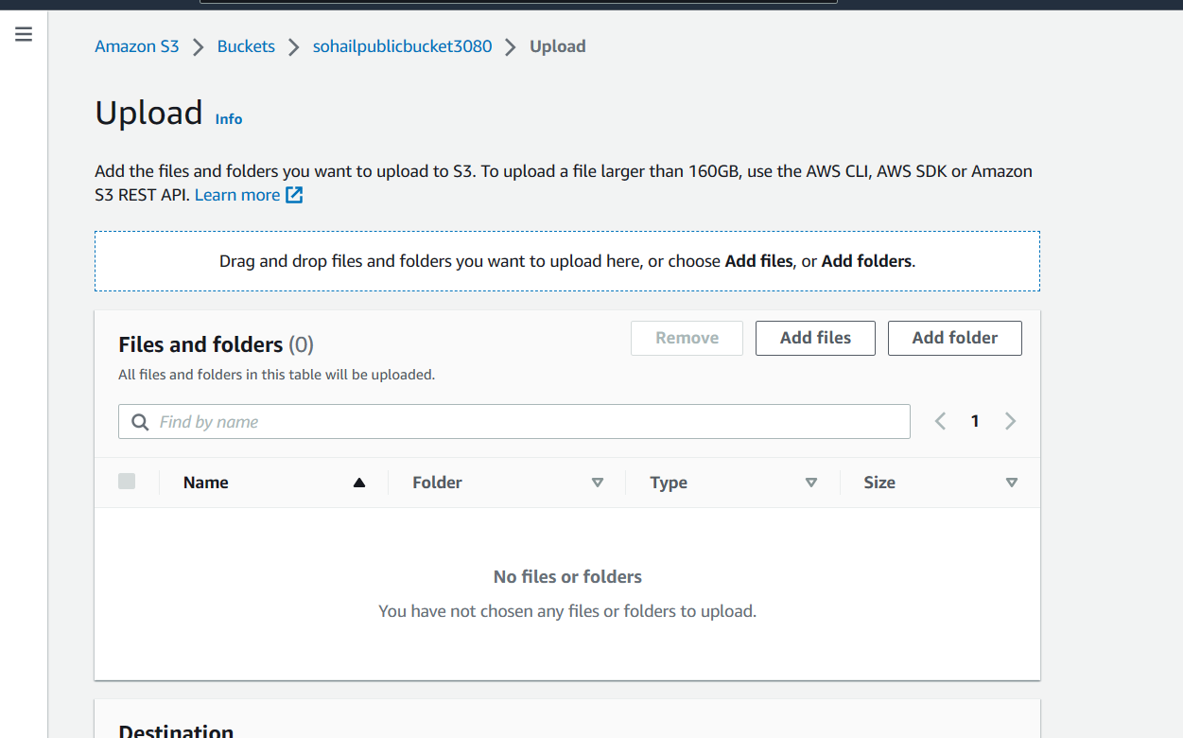

Select the file and click on **Upload**.

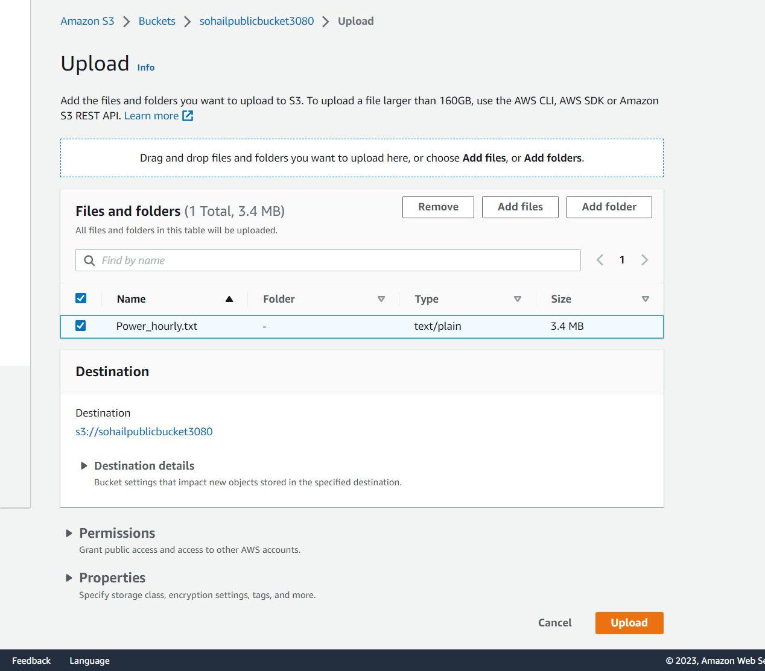

Then click on the file uploaded file on the upload status page.

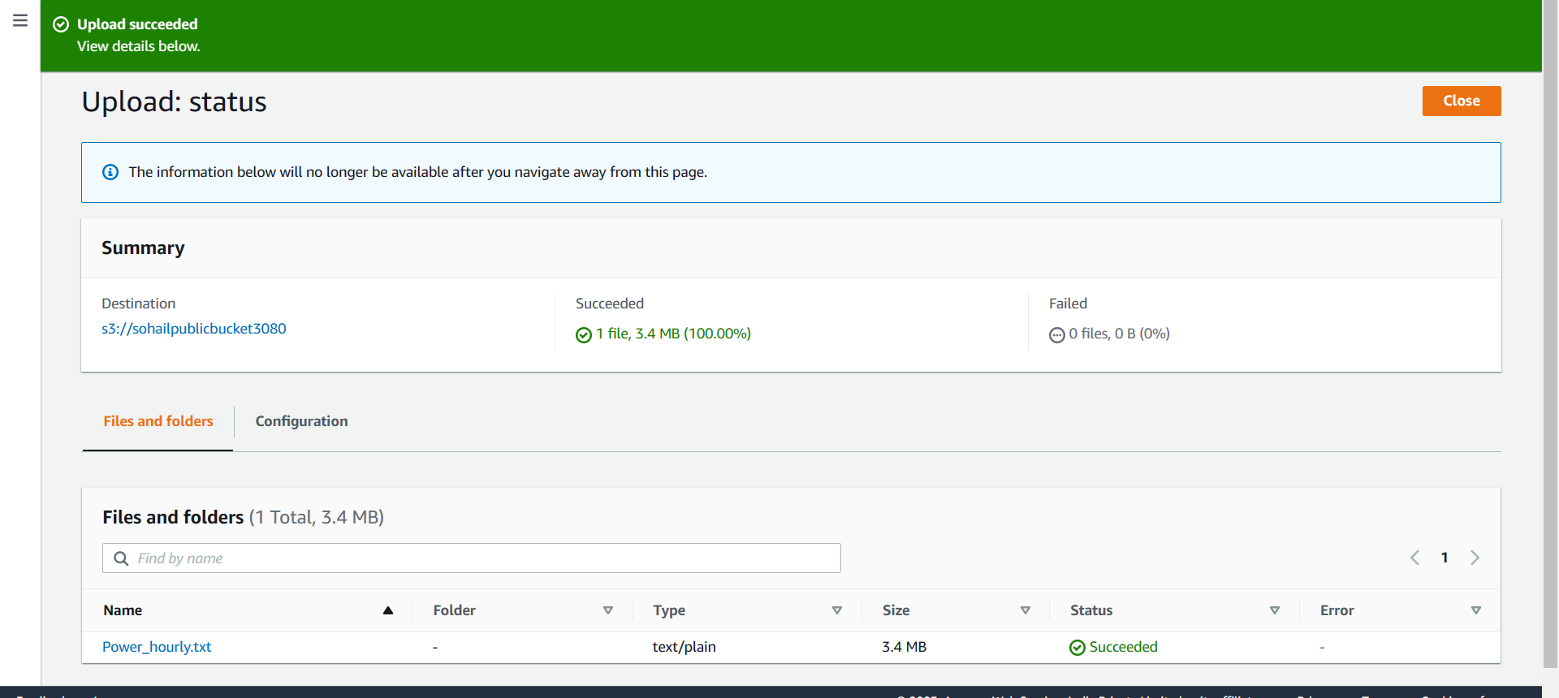

Copy the URL and open in new tab.

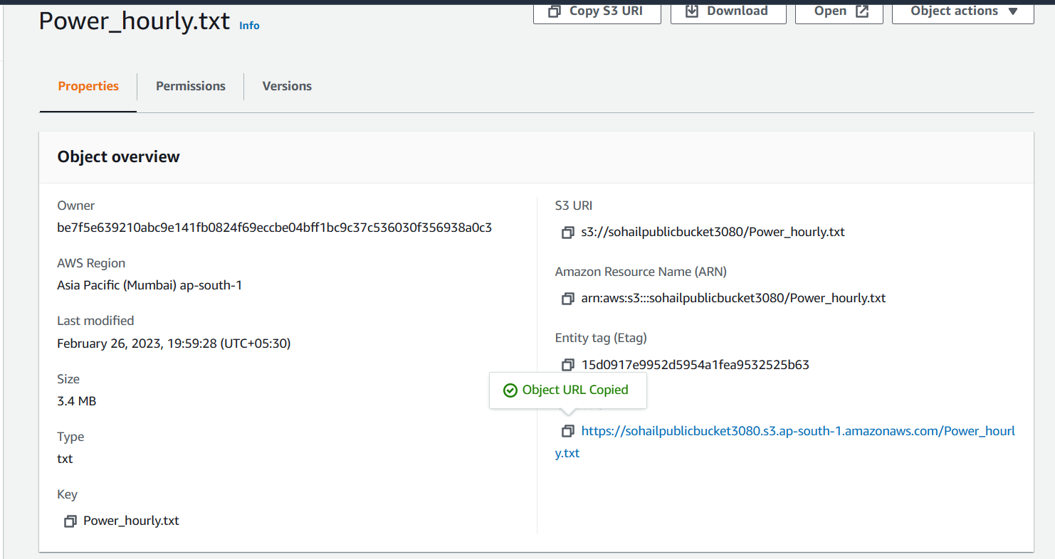

You can see **Object URL** cannot be accessed.

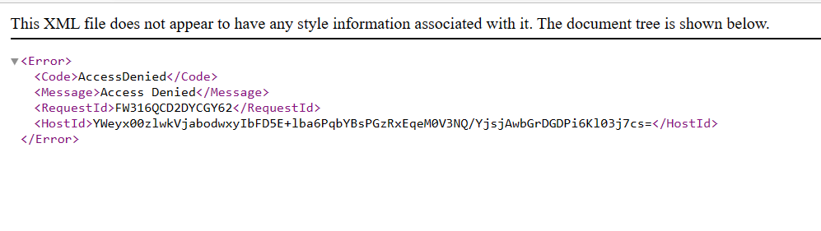

8. Next Go to **Permission** tab beside the Properties tab (it shows access control list).

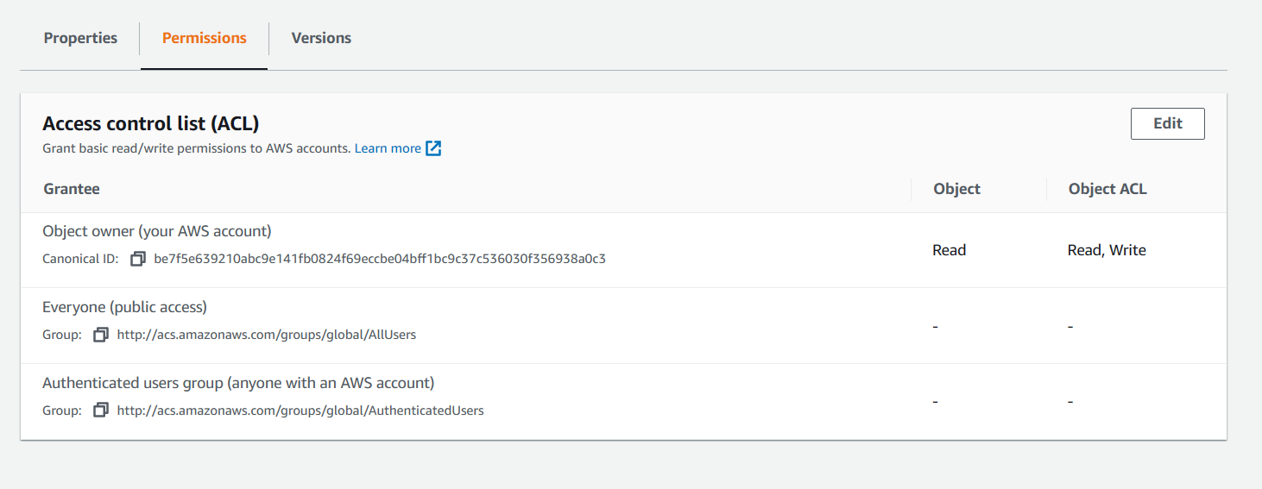

Next Click on **Edit.**

9. Under **ACL** section, In Everyone (public access), check two read boxes.

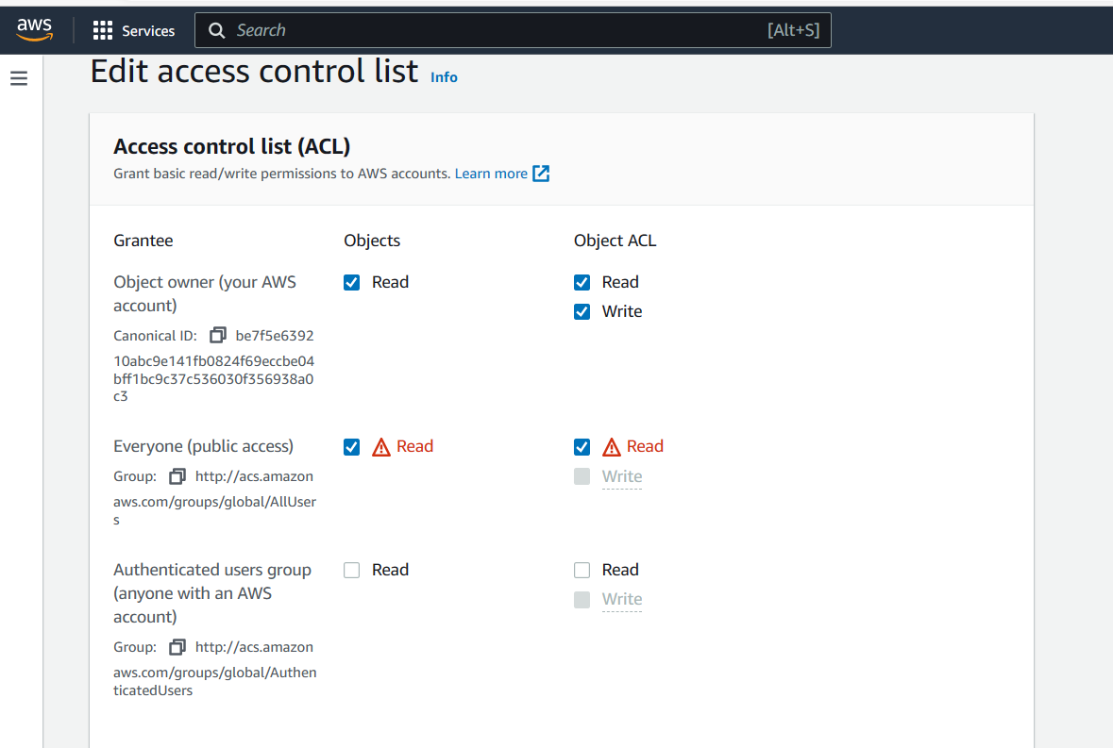

10. Then check **I understand the effects of these changes on this object.**

**Next C**lick on **Save changes**.

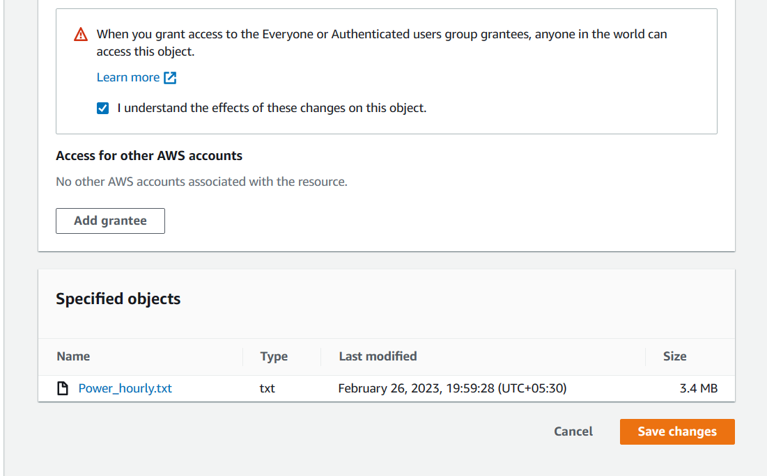

11. Now Refresh the object URL open in another browser you can access the file now.

